(Potential) Fix for “Domain isn’t available” error when trying to sign in



This error comes up when a user takes a computer home without signing into it while still in the office first.

So far, the solution was to have the user take the computer back to the office, sign into it, then take it back home.

This process outlines a way to potentially resolve the issue without having to make the user go back to the office.

1. Walk the user through signing in with the computer’s local admin (queenbee) account

(As a side note, to make sure the user typed the right slash, I ask them to read me what it says under the password box. If they say “███”, they typed the wrong slash.)

1. Have the user connect to the VPN via Global Protect with their own credentials
2. (Can be done before step 2 but be aware of possibly losing audio once the VPN connects) Have the user share their screen/pass over control using your preferred method (Webex/LogMeIn)
3. Open Local Users And Groups management either by:
   1. Window Key + R and type in “lusrmgr.msc”
   2. Type “local user” in the Windows search and select “Edit local users and groups” (pictured)

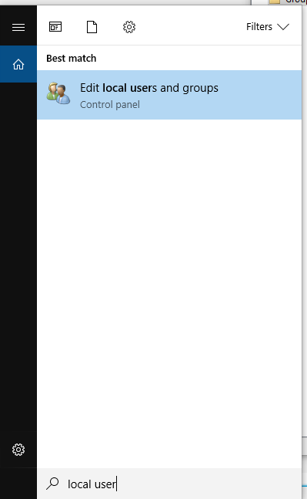

1. Select Groups (1), then right click on Users (2), then select Add to Group… (3)

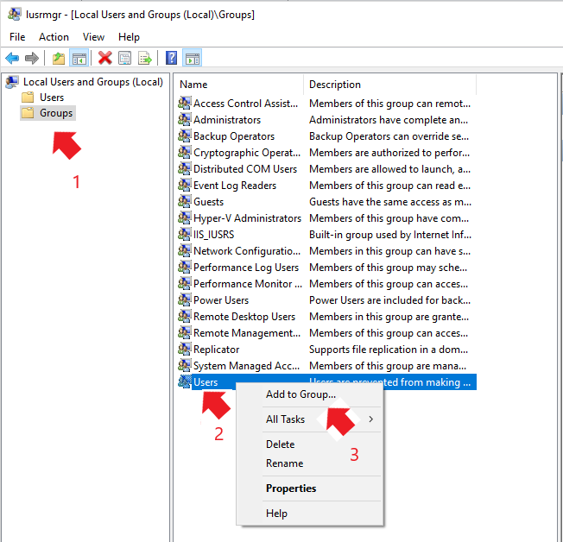

1. Click Add…
2. Type in the username of the user and click Check Names, verify that it pulls up the correct user
3. Click OK, then click OK
4. Sign out of the local admin account in Windows
5. Have the user log into their own account and it should work (or at least not give that original error message)

As of writing, this process has not been tested, but appears solid in theory. A potential issue that would prevent this fix would be if the queenbee password changed after the computer was disconnected from the corporate network.